***Target Audience: Internal Team/Investors who have reason to know and understand exactly what we’re building, how, and why. The intended style is precise enough for devs to know exactly what to do, yet remarkably concise so average folks can understand everything quickly.***

UncensoredGreats WhitePaper

The Internet has come to rely almost exclusively on Big Tech services as its information aggregators. This works well for current events, but leaves behind the content-rich information of the past. 95-99% of webpages, or the ‘deep web’, is inaccessible to search engines. As a result, everything that isn’t (1) search-engine optimized, (2) open-access, or (3) brand new, is lost to the everyday user.

Search engines have become the place for quick answers, forcing sites optimized for clicks into being shallow and uniform. Social, blogging, video sharing, or podcasting platforms offer tremendous depth and variety, but you can’t ever find anything. This is by design.

Since content platforms own the data they host, content richness and engagement are prioritized over searchability. Since aggregators do not own the data they point to, searchability is optimized for the clicks with minimal engagement. This conundrum should feel awfully familiar to any daily Internet user.

Search engines can’t benefit from content they point to because they don’t own it. Platforms can’t use the content of other platforms because they don’t own it. UncensoredGreats lets people put searchability and engagement under the same roof for any Internet content they wish to port because data ownership at every level falls to individuals.

UncensoredGreats is a distributed network in cypherspace where ‘code is law’, not just for money as with Bitcoin, but for generic data types: Text, video, and audio inside ebooks. Here, the content aggregator, host, and owner are one and the same, reporting only to a community of peers for governance.

### Structure

Blockchain technologies are borderless by nature. This is obvious geographically, but it also applies to the other imaginary lines we draw between the categories we work in. Since UncensoredGreats is P2P network powered by an infinitely scalable blockchain protocol, it best reflects a pan-industry platform of the core elements of the Web.

As such, this whitepaper is broken down by section, each describing the architecture and user experience for our Web3 equivalent of each Web2 Building Block:

* Search Engine (Home)
* E-Reader (Read)
* Storage (Drive)
* NFT-Marketplace (Earn)
* Portal (Aggregate)
* AI/LLMs (Create)
* Social Media (Share)
* Publisher (Internet of Books)
* DeFI Suite (Tokenomics)
* DAO (Governance)

### Home

All new users are greeted with a search bar and full access to all the search engines of other users without the need to sign in.

These search engines are curated and owned by other users we call *Librarians*. Each is a curated set of books with real-time full-text-search on their aggregate contents.

<gif or image of the experience, demoing how their typing pulls up those different quotes.>

Results are returned as book paragraphs that point to their origin at the source.

< gif or image of one of the quotes opening the annotation in-book. >

After sign-in, users can add these to their library as bookmarks, and use them with research and social features for microtransactions in ICP.

### Read

To a passerby, UncensoredGreats is like Google for Kindle, except all the books are free and all the search engines are owned by other users.

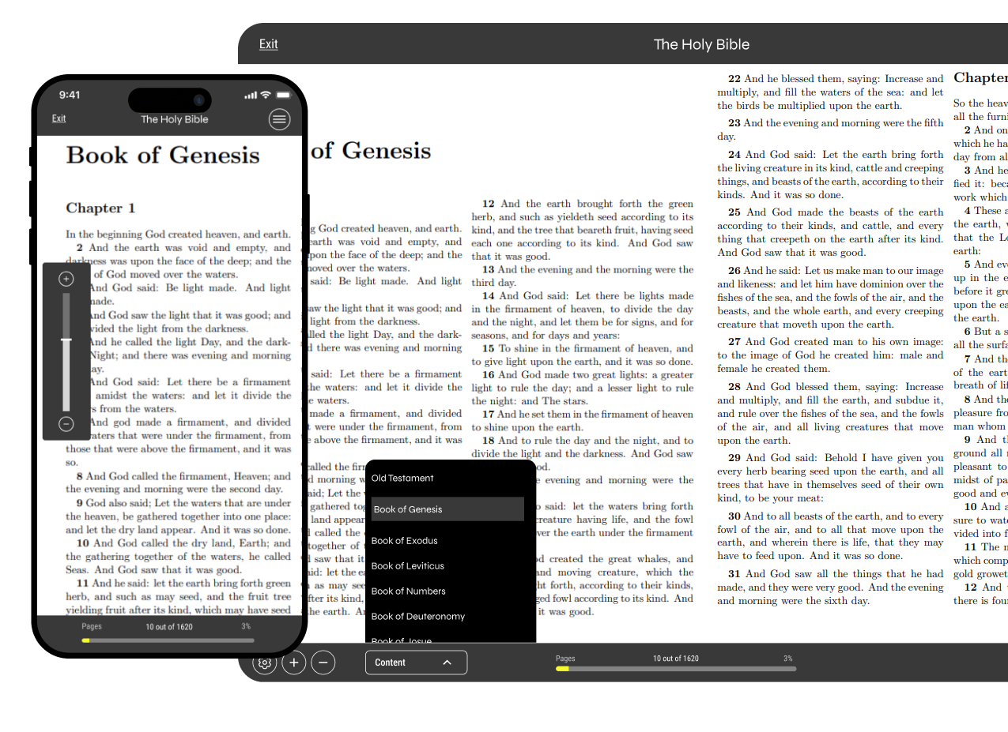

After sign-in and wallet topup, annotations can be saved much like that of a typical e-reader, except they become stored on-chain and made sharable. The anticipated microtransaction for saving these cards is one cent.

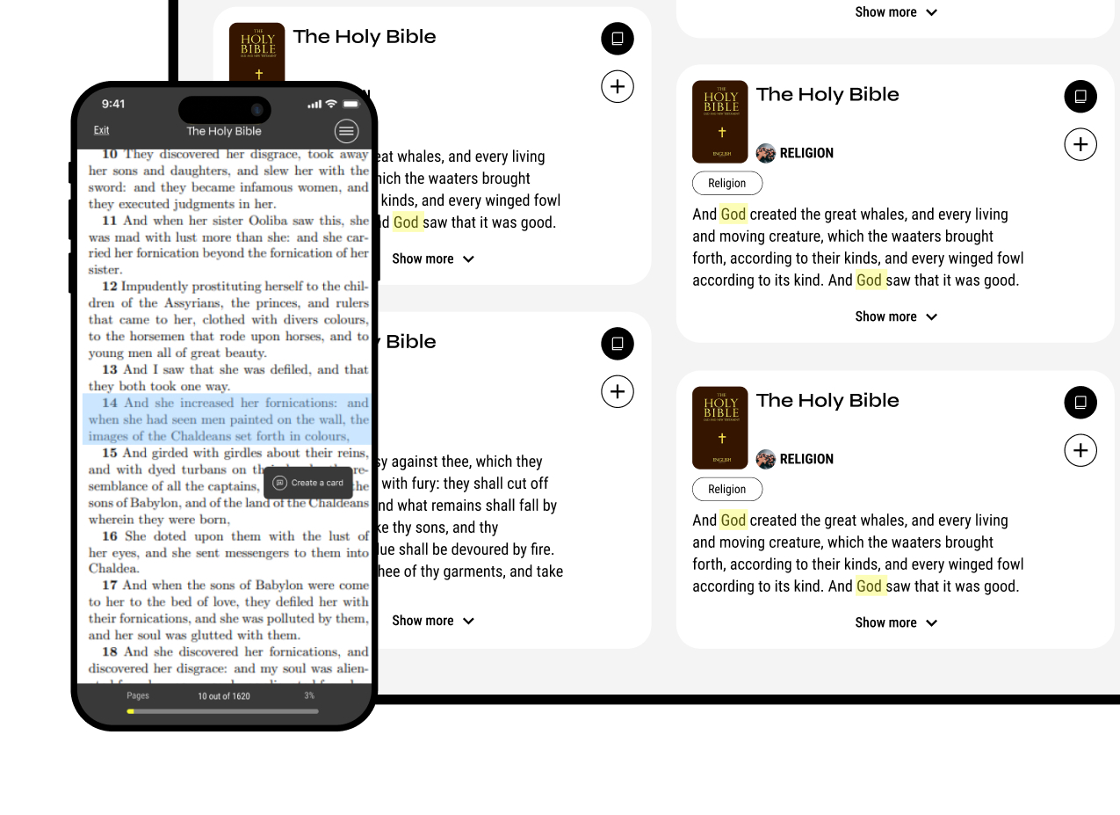

The books used are NFTs. UncensoredGreats does not own or hold them. Rather, *Librarians* (NFT owners) ‘rent’ read access of the .epub file to our canisters, making them free to read and interact with, but impossible to download or otherwise copy.

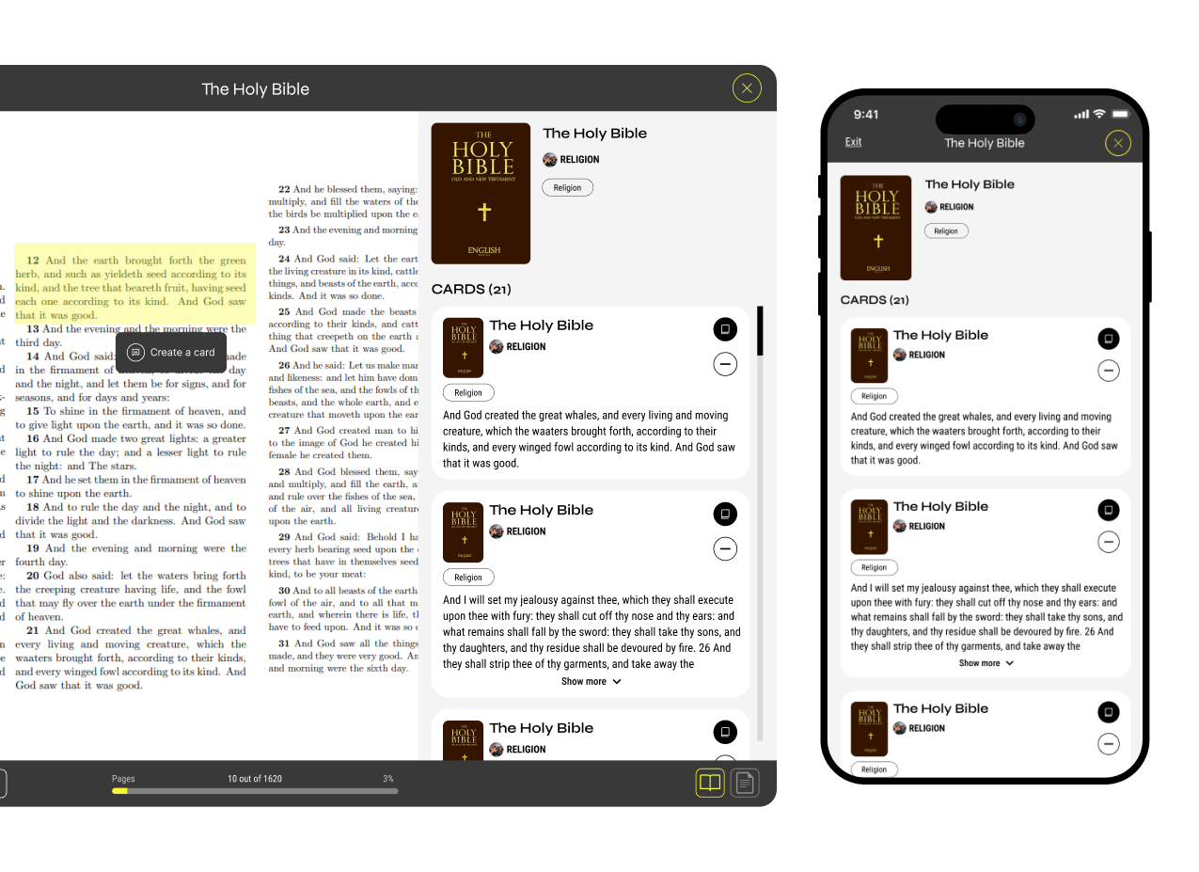

### Drive

All UncensoredGreats source material is in ebooks (.epub) because it is the superior content medium for high-value information. Storage is 100% on-chain and non-custodial, powered by Web3Disk.

To store ebooks, users become *Librarians* by creating their own asset canister through the UncensoredGreats Portal, and upload any books they like.

<web3disk portal UI for UCG (showing the book part. This can be generic for now since we don’t have Web3Disk running.)>

Once connected to their UncensoredGreats Account, these books become generally available in-app. Librarians use these books to produce custom search engines. With a single click, every paragraph in their chosen book(s) is parsed and added as a potential result in their search engine.

Search engines are built with pre-configured Docker Containers (Meilisearch for full-text search and Qdrant for vector search) and deployed via a DAO canister to the Cosmos-based Akash Network. *Librarians* pay the cost of hosting ebook files in their asset canisters and for the search engine hosting in ICP which is fully managed from their UncnesoredGreats Portal.

< Image of the current manager we have for the Portal (this manager will later add a connection to the Web3Disk asset canister) >

This ownership-based canister model allows each party to retain power over the other. *Librarians* are ‘renting’ the ebook file to UncensoredGreats so long as they are happy with how it is used; while UncensoredGreats, much like any ‘tenant’, can leave the property behind (according to a governance model, if the ebook is shown to be corrupted or pirated).

This push-pull relationship between human contributors and DAO canisters is made enforceable with an incentive mechanism with Book NFTs at its core.

### Earn

Basically people get paid based on the likes of bookmarks by others.

All source material on UncensoredGreats is owned by a single person at a time.

* Books are NFTs, minted with X properties.
* Tradable in the marketplace, 5% royalty. But also earn a % onn usage (need specifics).
* Combating Duplication issues. (Duplicates can be revoked, and the original will have the right traction from likes anyway). But it’s the metadata that’s valuable, which tracks usage, so the first/most-used one retains the visibility.

**Gotta figure out how to reconcile this with the tokenomics section**

### Aggregate

All the search manager stuff

### Create

All the AI Stuff here.

### Share

The social stuff

### Internet of Books

The cons of regular search engines:

1. Sponsored content promotion against user`s will.

2. Search result is usually adjusted to users region that does not serve the original purpose of bettering the content but instead limits and censors the presented information.

3. Usually limited to certain types of content.

4. Search algorithm based on metadata and not the actual content:

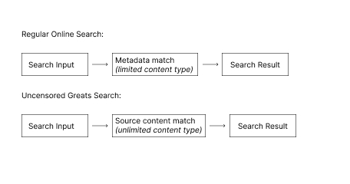

Main pros of using UG search engine:

1.Unbiased result matches

2.Searching through all formats of available content (audio, video, text).

3. Matches via actual source`s content.

4. Search results presented in short “straight-to-the point” format.

5. Search result cards can be saved and stored inside the platform for further use according to one's taste and needs.

### Tokenomics

As I code this I’m going to track my notes and progress of the real implementation here: <https://docs.google.com/document/d/1GrM9pkNFC41Ouevs-DlvfTG2AwuboyRM9CPV1VeKyVc/edit?usp=sharing>

Search and reading is free for users, but the hosting is paid for by librarians, and both have to get paid. So here’s the revenue model.

***

When users log in they need to load up on ICP to perform certain interactions. They can choose to convert those ICP to any other ICRC-2 token (CREDITS) for 20/0.01 ICP. These credits are spent (burned) for platform operations such as bookmarking.  
  
When a credit is burned, 1 cent used to mint it becomes claimable, 50% goes to the book owner, 50% goes to the DAO/Stakers.

When a user burns credits, their likes become more powerful and help to distribute UCG.

I figured out how to distribute the thing.

Search is paid for by akash, non-custodial. Ebook hosting is paid for by Web3Disk users, non-custodial. Our only overhead is storing the regular app stuff (bookmarks/blogs/AI), so pretty cheap.

We’ll set it up as a full-featured app without login except for saving and using AI stuff. That costs ICP.

50% of that ICP goes to the book owner of the liked thing, 50% goes to us, or some split like that. That’s it!

Now for the distribution:

Based on the amount of saved cards you have, in a logarithmic fashion, dUGC (delegatedUCG) will land in your account in drip/faucet. This will be allocated to others based on your likes on social posts in a use it or loose it type fashion. This would be very difficult to bot attack, and very meritocratic imo. Also doesn’t cost us much of anything, and doesn’t matter when things fully emit since real earners are getting ICP.

### Governance

We’re a DAO, bla, bla, bla. Canister architecture should be configured to put complete control to a self-constructed DAO or perhaps on the SNS. Not sure yet. This also needs to be done last.

* Home - Search Engine
  + Get source cards and can save them.
* Read - E-Reader
* Book Portal - Drive
  + Web3 Disk Sovrieng Storage.
  + Upload Parameters.
  + These become NFTs
  + These NFTs are tradable and usable in search…
* Earn - NFT Marketplace
* Manager - Non-Custodial Aggregators
  + Manager Tabs and their function.
  + Off-chain, maybe later on-chain.

Vector Search Engine

* + Equally sophisticated manager for cards already saved.
  + Perhaps one for each user’s own personal collection.
  + Perhaps on-chain, maybe off-chain.
* AI - LLMs
  + Apply AI content generation on Source Cards
  + Likely non-custodial plugins.
* Share - Full Featured Social Experience
  + Iceberg Charts.
  + Sharing and commenting (somehow all without hyperlinks).
* Internet of Books - Book Publisher
  + UncensoredGreats Service suite to create ebooks from full podcasts, youtube channels, personal websites, etc.
* Tokenomics - DeFI Suite
  + Distributions. Mining process.
  + Staking
  + Brief utility in revshare and governance.
* Governance - DAO (coprite management)
  + Code updates and NFT transfers of pirated content.
* Conclusion